**Single Displacement & Combustion Reactions Notes**

A Single Displacement Reaction occurs when one element displaces (or replaces) another element in a chemical compound

**General form: A + BC → AC + B** In this reaction, B has been replaced by A in BC, leaving B to exist by itself

Types of Single Displacement Reactions:

A metal displacing another metal in an ionic compound A metal displacing Hydrogen in water or an acid

Al(s) + FeCl2(aq) → Fe(s) + AlCl3(aq) Mg(s) + HCl(aq) → MgCl2(aq) + H2(g)

A non-metal displacing another non-metal in an ionic compound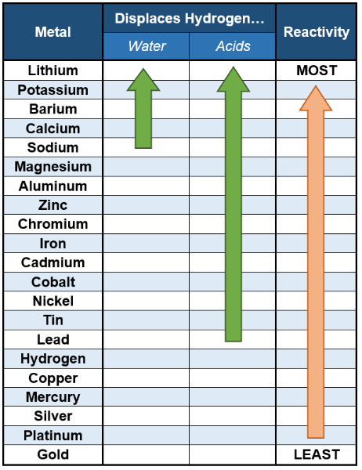

Cl2(g) + NaBr(aq) → NaCl(aq) + Br2(l)

Some metals are more reactive than others and can be ranked relative to one another. This is called the **Metal Activity Series.** We can use the activity series to predict the products in Single Displacement Reactions.

**A metal (element) higher up on the series will replace any element lower down**

Zn(s) + CoCl2 (aq)→ Co(s) + ZnCl2(aq)

Fe(s) + Mg(NO3)2(aq) → No Reaction

*Displacement of Hydrogen*

Notice that **Hydrogen** is also on the list. **Anything above Hydrogen will displace**

**it in an *acid***

Some highly reactive elements can also replace the **Hydrogen** in water

* These include: Lithium, Potassium, Barium, Calcium and Sodium
* Metal will take **Hydroxide** from the water, leaving **H2 Gas**
  + Na(s) + H2O(l) → NaOH(aq) + H2(g)

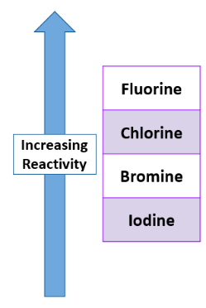

Activity Series of Halogens

There is also a series for **Halogens** that can be used to determine whether certain anions can be replaced in reactions

* This series works the same way as the Metal Series (higher replaces lower)

Cl2 + NaBr → NaCl + Br2

Cl2 + NaF → No Reaction

**Combustion Reactions**

A **combustion reaction** occurs when a substance is reacted with oxygen. This reaction releases energy in the form of **heat and light**, as well as several oxides. Many things can undergo combustion, but most of the compounds that do are known as **Hydrocarbons**

* + A **Hydrocarbon** is a compound made exclusively out of **Carbon** and **Hydrogen** (sometimes Oxygen)

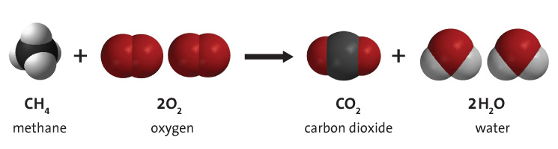

Here is a table of common Hydrocarbons

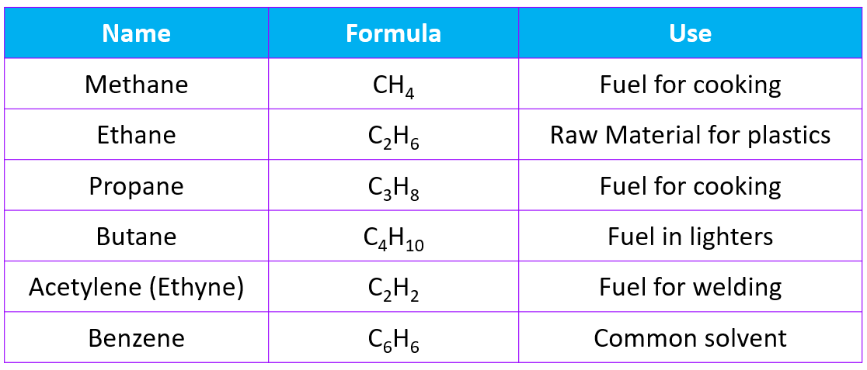

**Complete Combustions** reacts to produce the same products all the time: Carbon Dioxide & Water in plentiful oxygen

* General formula: ***CxHy + O2 → CO2 + H2O***
* This will produce a **blue** flame , as there is plenty of oxygen for the reaction

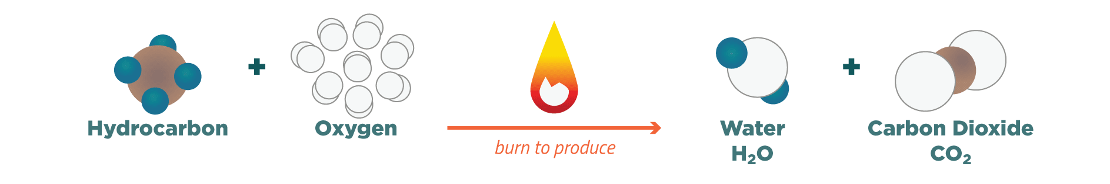

**Incomplete Combustions** reacts to produce the a variety of products:

Carbon Dioxide, Carbon Monoxide, Carbon (soot) & Water in limited oxygen

* General formula: ***CxHy + O2 → C?H?+ CO2 + CO + C + H2O (C?H? represents various smaller hydrocarbons that result from incomplete combustion of the larger fuel source)***
* This will produce a **yellow/orange** flame , as there is limited oxygen for the reaction

